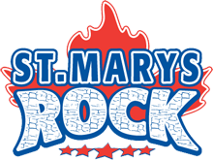
St. Marys Minor Hockey Association www.stmarysminorhockey.ca
2016 BOYS AE TOURNAMENT APPLICATION
Thursday, Oct. 20 to Sunday, Oct. 23, 2016
The St. Marys Minor Hockey Association invites you to apply for participation in our 10th Annual Rock Tournament at the St. Marys Pyramid Centre. Teams are guaranteed three games in a round robin format. Additional game(s) are possibly if the team advances to playoff(s).
** There are two steps to secure your spot in our tournament. **
- Go to our website and fill out the online reservation form and give a $200 non-refundable deposit. You can use your PayPal account or by credit card through PayPal. Follow the Tournament link on the top toolbar at www.smmha.ca.
- Complete this form and mail it with the BALANCE due to Kristene McCurdy - Tournament Convenor.
The tournament fee includes all gate fees. Applications will only be considered when a deposit is received through the website and this application is received accompanied by a cheque for the balance. Please provide a phone number and email so that you can be contacted regarding acceptance into the tournament. Deadline for the application, team roster, and cheque is one month prior to the tournament date. Please make cheques for the balance (not including the $200 deposit) payable to St. Marys Minor Hockey Association.
The round robin games begin Thursday night and will conclude on Sunday morning. Championship games will be played on Sunday afternoon. All game times given are final (no changes will be made). If your team withdraws from the tournament and a replacement is not found, no refund will be given. All teams must be AE Group 2, 3 or 4 (or equivalent).
Level | Novice | Atom | Peewee | Bantam | Midget
Period Length | 10-10-10 | 10-10-10 | 10-10-15 | 10-10-15 | 10-10-15
Registration Cost | $775 | $775 | $775 | $875 | $875
Deposit (via website) | $200 | $200 | $200 | $200 | $200
Balance (via cheque) | $575 | $575 | $575 | $675 | $675

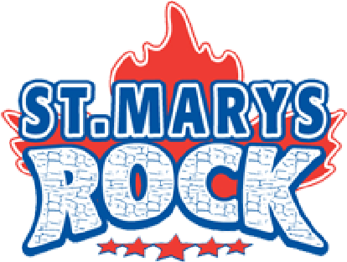
St. Marys Minor Hockey Association www.smmha.ca2016 BOYS AE TOURNAMENT APPLICATION
Thursday, Oct. 20 to Sunday, Oct. 23, 2016
ASSOCIATION: | TEAM NAME: | LEAGUE:
DIVISION: (Circle one)  Novice Atom Peewee  Bantam Midget | CLASSIFICATION: (Circle one)  GROUP 2 3 4 | ROSTER INCLUDED:
SWEATER COLOUR:  Home -  Away - | MANAGER: | EMAIL ADDRESS:
ADDRESS: | TELEPHONE #: | ALTERNATE CONTACT:
I, the undersigned team official, hereby declare that all of our team players involved in this tournament are signed and carded in accordance with the rules of the hockey governing body in our area. I understand that our team will have to present approved player and team official roster at the time of application/registration before playing the tournament. I will present all permission forms for tournament participation, duly completed and authorized.
SIGNATURE: | DATE:
NAME (print): | TITLE:
For Office Use Only...
Date of Receipt: | Date Notified:
Please return your completed application and cheque to:
Kristene McCurdy 1764 Perth Road 123, RR#3 St. Marys, ON, N4X 1C6
Telephone: (519) 272-3238 Email: kdmccurdy@hotmail.ca

